Kildonan House

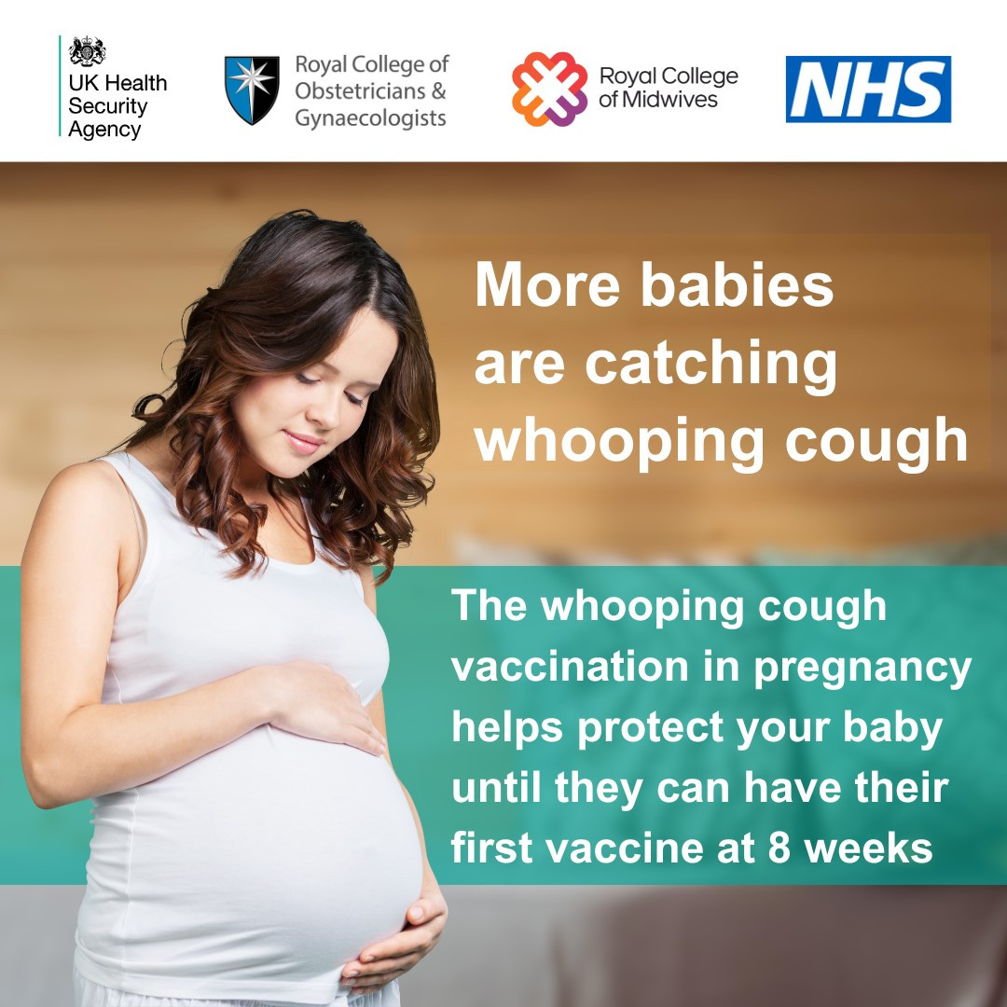**VACCINE NEWSLETTER**

NEW RSV VACCINE

**Respiratory Syncytial Virus (RSV)** is an infectious disease of the airways and lungs. RSV infection often causes symptoms similar to a cold, including cough, sore throat, sneezing and runny or blocked nose. It can also make you become wheezy or short of breath and lead to pneumonia and other life-threatening conditions. There is no specific treatment, and most infections will get better by themselves. Every year thousands of older adults need hospital care for RSV, and some of them will die. RSV can be more severe in people with medical conditions such as heart or lung disease or a weakened immune system.

**How do you catch RSV?** RSV infections can occur all year round but cases peak every winter. RSV can spread through coughs and sneezes. You can help to prevent the spread of the virus by covering your mouth and nose when you cough or sneeze (ideally with a tissue, or else into the bend of your elbow), and you can wash your hands frequently to reduce the risk of picking up the virus. Even with these measures it can be difficult to avoid RSV infection.

**RSV infection is common in young children but is most serious for small babies and for older people.** Who should have the RSV vaccination? Everyone turning 75 years old on or after the 1 September 2024 will be offered a single dose of RSV vaccine. This is because older adults are more at risk of serious complications from RSV. You can still get the vaccine up to the day before you turn 80. For the first year of the programme, the vaccine will also be offered to those who are already aged 75 to 79 years on 1 September 2024 as part of a catch up programme. **If you are born between 2nd August 1944 and 31st August 1950 you are eligible.**

**Are there any other people eligible for the RSV vaccine?** Pregnant women are also being offered the vaccine to protect their babies from RSV.

**Can I have the RSV vaccine at the same time as my COVID-19 or flu vaccine?** RSV isn’t normally arranged to be given at the same appointment as your COVID-19 or flu vaccines. In certain clinical circumstances, your doctor or nurse can safely offer them at the same time. Can I have the RSV vaccine at the same time as the shingles or pneumococcal vaccine? Yes, you can have these vaccines at the same time.

Whooping Cough Vaccine

Whooping cough (pertussis) cases continue to increase and babies who are too young to start their vaccinations are at greatest risk.

Whooping cough can be serious for babies and may lead to complications resulting in hospitalisation and even death. Sadly, between January and April 2024, eight infants died from whooping cough.

If you are pregnant, you can help protect your baby by getting the whooping cough (pertussis) vaccine between 16 and 32 weeks. Getting the whooping cough vaccine whilst pregnant offers very effective protection for new babies.

Pneumococcal Vaccine

The pneumococcal vaccine helps protect against serious illnesses like pneumonia and meningitis. It’s recommended for people at higher risk of these illnesses, such as babies and adults aged 65 and over.

What the pneumococcal vaccine is for:

The pneumococcal vaccine helps protect against some types of bacterial infections that can cause serious illnesses like:

Meningitis and infection in the brain and spinal cord

Sepsis a lift threatening reaction to an infection

Pneumonia an infection in the lungs

It can also help protect against other illnesses such as sinusitis and ear infections.

Who should have the pneumococcal vaccine?

Babies 1st dose at 12 weeks and a booster at 1 year

People aged 65 and over 1 dose when you’re 65

Children and adults at higher risk of getting seriously ill at least 1 dose (some people may need extra doses or regular doses)

Shingles vaccine

**People aged 50 years and over with a severely weakened immune system**

If you have a severely weakened immune system and are over 50, you remain eligible and there is no upper age limit.

**Eligibility if you turn 65 in 2024 (Born between 2nd September 1958 and 1st September 1959) - You will be eligible to have your shingles vaccine once you turn 65**.

**Individuals aged 65 years who are not eligible for the vaccine this year**

Anyone whose 65th birthday occurred before 31 August 2024 will not be eligible until they turn 70. You will be invited by your GP practice to have the vaccine.

Eventually the vaccine will be offered to everyone over 60 but this is being phased in to make sure the NHS can deliver this programme effectively alongside other seasonal and routine vaccination programmes and other healthcare priorities.

**Individuals aged 66 to 69 years**

Individuals aged 66 to 69 years will have to wait until they become 70 to receive shingles vaccine.